Seller Analytics Assignment

Outsiders/Lowest turnover

To begin with, realizing that the network is located in Brazil, where the standard of living varies depending on the city, I decided to determine whether the success and turnover of sellers is related to the cities in which they work. Having calculated the turnover of each seller individually, I noticed that the turnover of a relatively large number of sellers is 1-2 orders, I decided to find out in which cities they are located. Acquired information: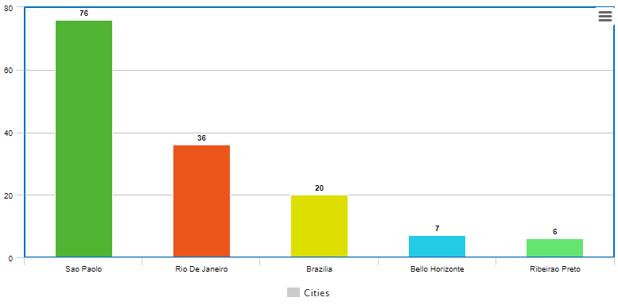

As we can see, the city of San Paolo is the leader by a strong margin in the number of sellers with low turnover, which means that there are too many sellers for this city. On the other hand, this can be justified by the fact that Sao Paolo is the largest city in Brazil by population (population 19 million).

Leaders/ Highest turnover

Having sorted and seen the maximum turnover of sellers, I set the limit at 300 orders and considered a relatively small number of sellers.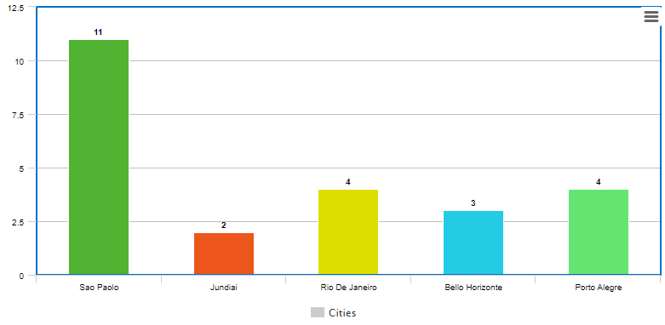

As we can see, Sao Paolo is indeed a leader in both cases, due to the fact that it is the largest city in Brazil. However, cities such as Porto Alegre and Jundai stood out. Relatively small cities with a number of leaders in demand.

Conclusion:

From the information received, we can conclude that the company has an excess of sellers in large cities of the country. To increase the amount of benefit, the company should calculate the percentage of sellers in the cities of Sao Paolo and Rio De Janeiro who are in quite high demand, and it will be clear that the percentage is quite small, hence the conclusion that the number of sellers in large cities should be reduced, because they do not bring profit to the company, but on the contrary, they can work at a loss (depending on their wages)

There is also a file in the folder called Sellers Analysis.ipynb, which shows the work done to obtain the above information.